Name__________________________________ Period_______________

War of 1812 Tribute CD!

Instructions: In groups of two you are to design the front and back of the CD cover for the tribute album

-Front Cover: Title of the record and a big color picture of the war of 1812. Use your Ipad to help you find an image. Google War of 1812

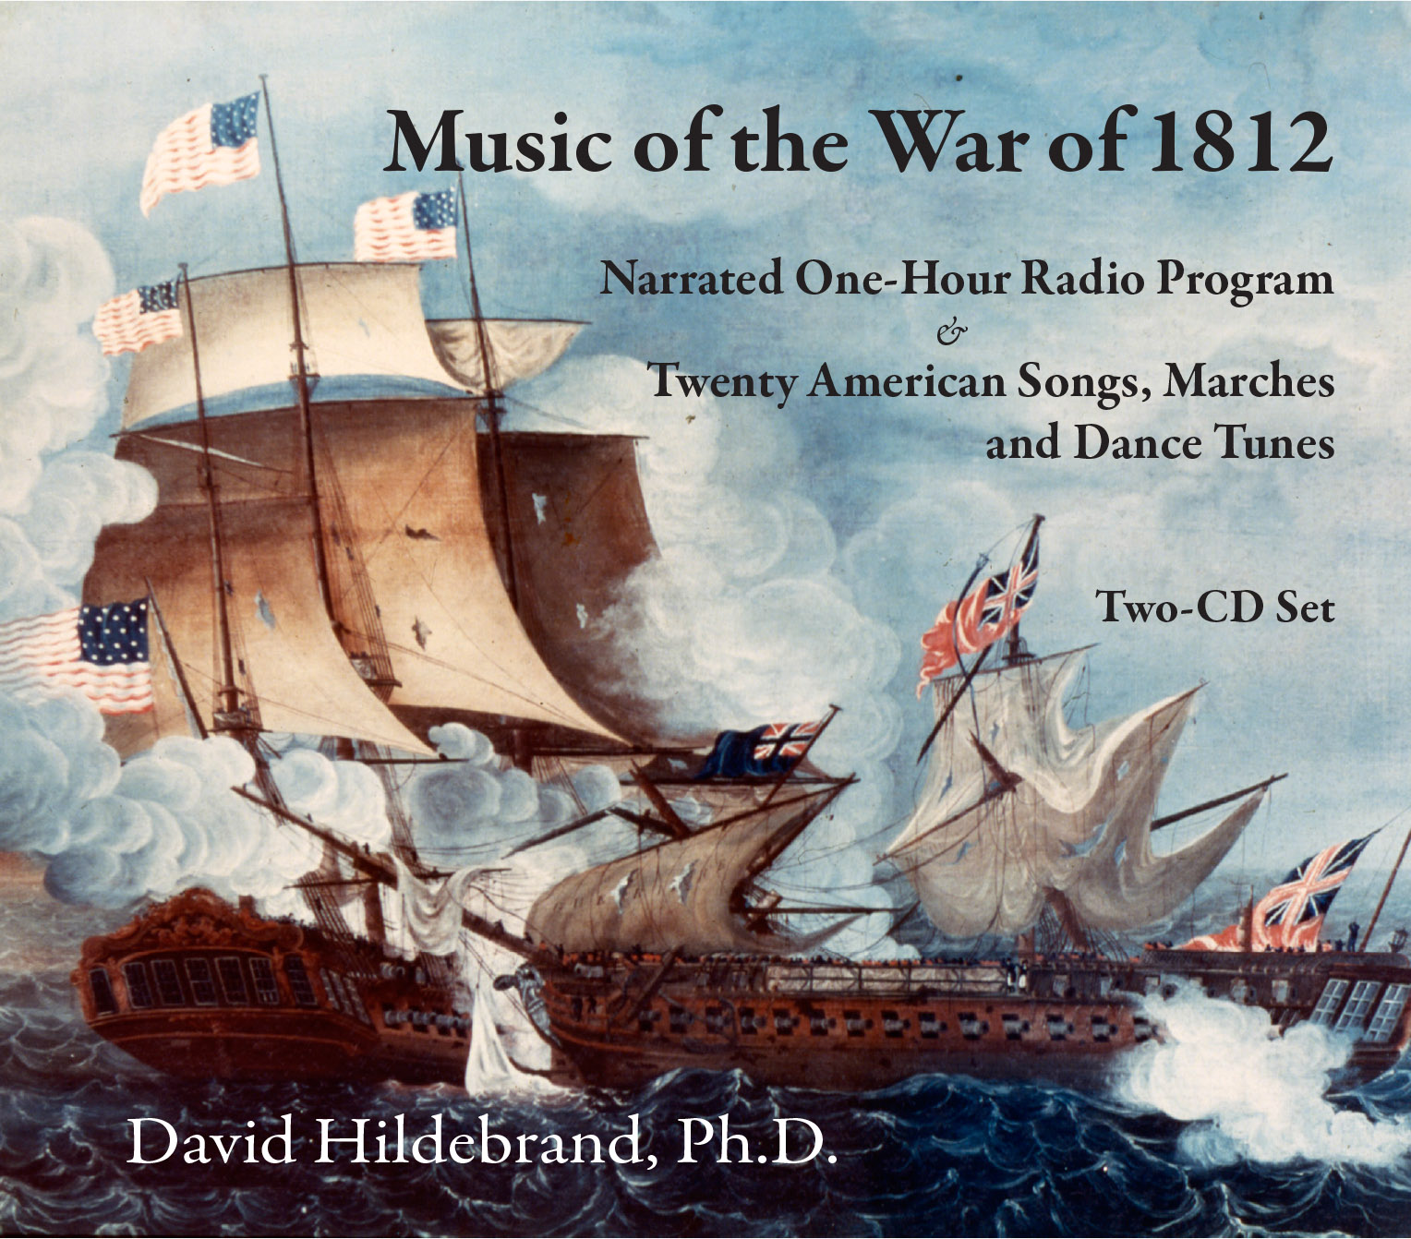

Back Cover:
- List of 9 songs with War of 1812 titles! Use your notes to help you!
-3 songs over the causes of 1812
-3 songs over famous events in the war
-3 songs over the effects of the war for the US

Be creative on the song titles! For example a song about the USS Chesapeake surrendering might be called “We gave up the ship and now we want it back!” because the Captain famously said, “Don’t give up the ship!”

For every song pick an artist or artists you like who will perform the song and list their names or group names underneath the song.

Example: Track 1) “We gave up the ship and now we want it back!”
-by History Heaven featuring the Cannon

Have a color design for the back of your album featuring a small War of 1812 picture.
