Glue This Side Down

North Carolina Geography
- North Carolina has 3 geographic regions
A.
B.
C.
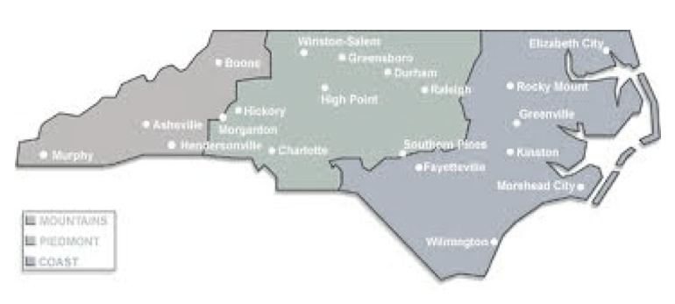
Coastal Plain
- This is the most _____________________________ region of the state (the farthest to the right)
- It is the most ________________ region of North Carolina
- The soil is a black sandy type of soil called _____________
- The Coastal Plain contains two sub-regions:
1.
2.
Outer Banks
- These are a long chain of sandy ____________________ off the coast of North Carolina
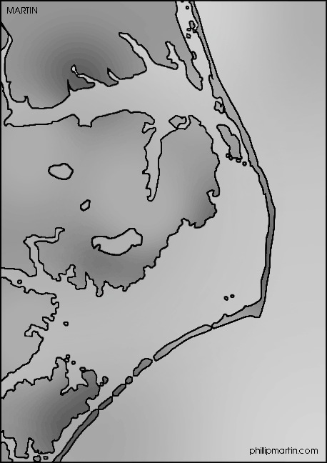
- The Outer Banks is also made up of a series of __________________ which is when land juts out into the ocean.
- North Carolina has 3 capes:

Outer Banks (Continued)
- 5 large bodies of water separate the Outer Banks from the rest of the coastal Plain. These are called ____________________.
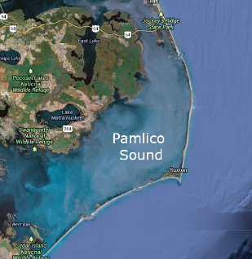

Piedmont Region
- This is in the ______________________ of the state
- The ________________________________________ is the Western (LEFT) boundary of this region
- The __________________________________________ is the Eastern (RIGHT) boundary of this region
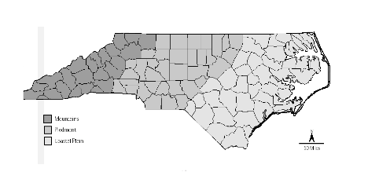
- This is the most urban region of the entire state
- This regions has a reddish _________ soil

Mountain Region
- This is the most _________________ region of our state
- The ___________________________ is the Eastern (RIGHT) boundary
- The ___________________________ form the Western (LEFT) boundary
- _____________________________ is the highest mountain in North Carolina
- ______________________ is to the West of the Mountains
- This is the most _____________ part of our state
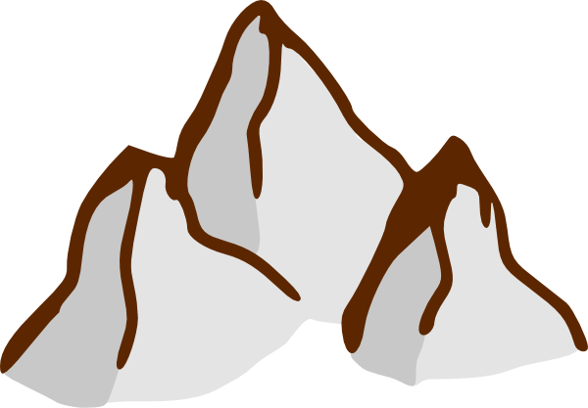

Revisit your Focus Question from this morning. Knowing what you know now, which of the three major regions of NC would you most like to live and why?

