“American Progress”
by John Gast 1872

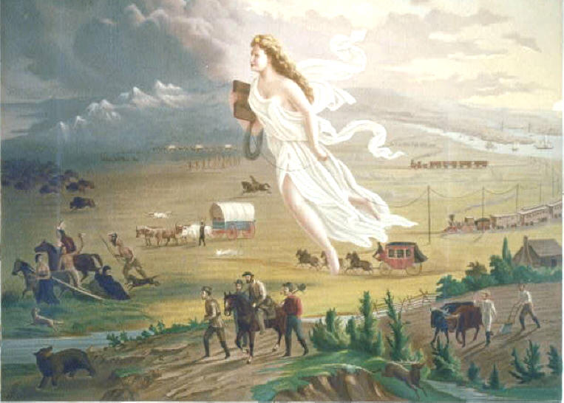

Picture Analysis Worksheet

Study the painting and use the chart below to list the people or animals, objects, and activities that you see in the painting. Be specific.

People or Animal | Objects | Activities

Answer the following questions:
1. What does the woman represent?

2. Why do you think the picture moves from light to dark?

3. What symbols of westward expansion do you see in the painting?

4. How do you think the painter feels about westward expansion?

5. What questions do you have about the painting?

