Japanese Internment Photo Analysis
Picture | Analysis of picture
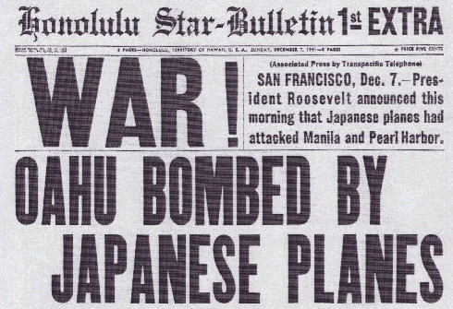 | - Where was this newspaper printed? How can you tell?  - Does the newspaper’s location have something to do with how it depicted the events of December 7? Why?
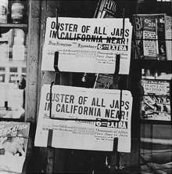 | 1) What does the headline here say is going to happen to Japanese in California?  2) Why do you think there was a desire to remove Japanese Americans from the west coast after Pearl Harbor?
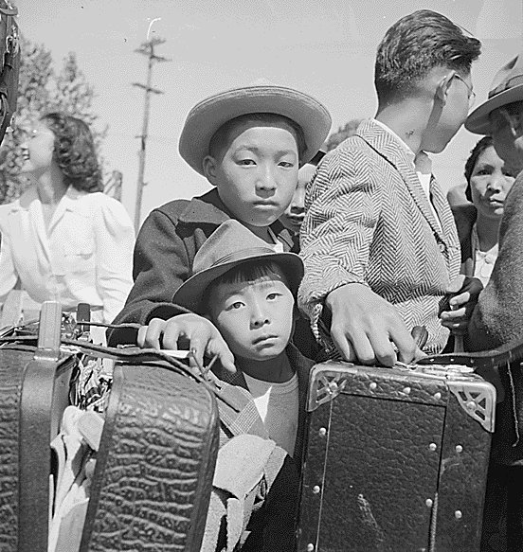 | - What sticks out to you in the photo? List details that you notice.  - What are the people doing?  - What emotions might these people be experiencing? How can you tell from the photo?

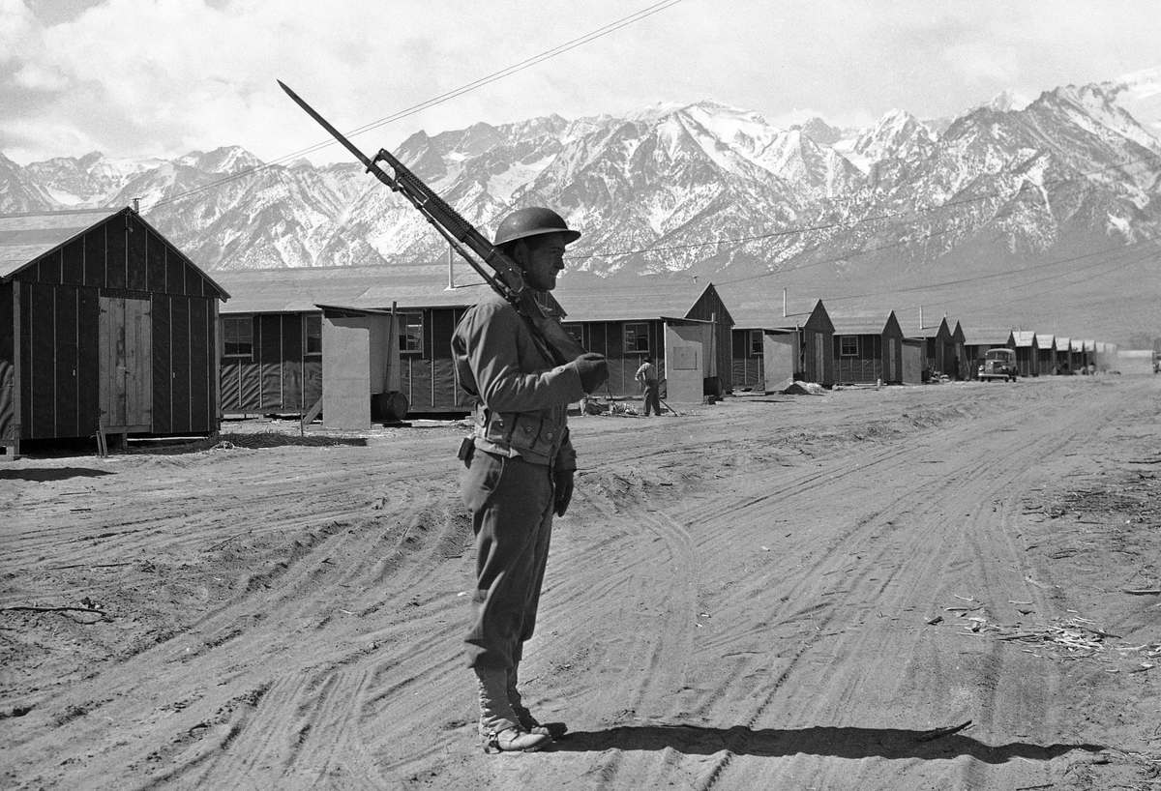 | - What details do you notice here?  - What does the photo tell you about life at the internment camps?
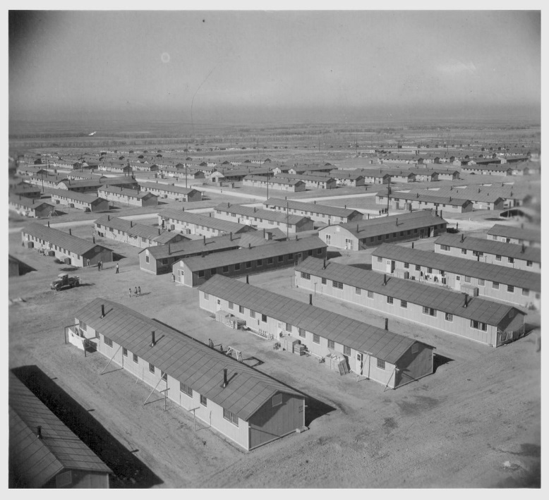 | - What sticks out to you in the photo? List details that you notice.  - On a scale of 1-5 (5 is the highest), how would you rate this camp on how inviting it appears to be? Why?  - What does the photo tell you about life at the internment camps?
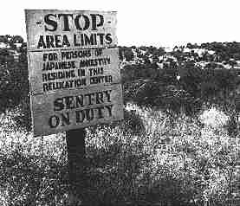 | - What sticks out to you in the photo? List details that you notice.  - What does the photo tell you about life at the internment camps?

