Fakebook – Startup Guide

• "Fakebook" is a free tool at www.classtools.net which allows teachers and students to create imaginary profile pages for study purposes.
• Use "Fakebook" to chart the plot of a book, the development of a character, a series of historical events, debates and relationships, and so on!
• You can save your work and edit it again later.

1. Enter the name of your character (or object, or concept, or whatever!)
An image will automatically appear. Click on this if you would rather change it to an image uploaded from your computer.

2. Add an appropriate cover image. Search Google Images (“Facebook cover images”)

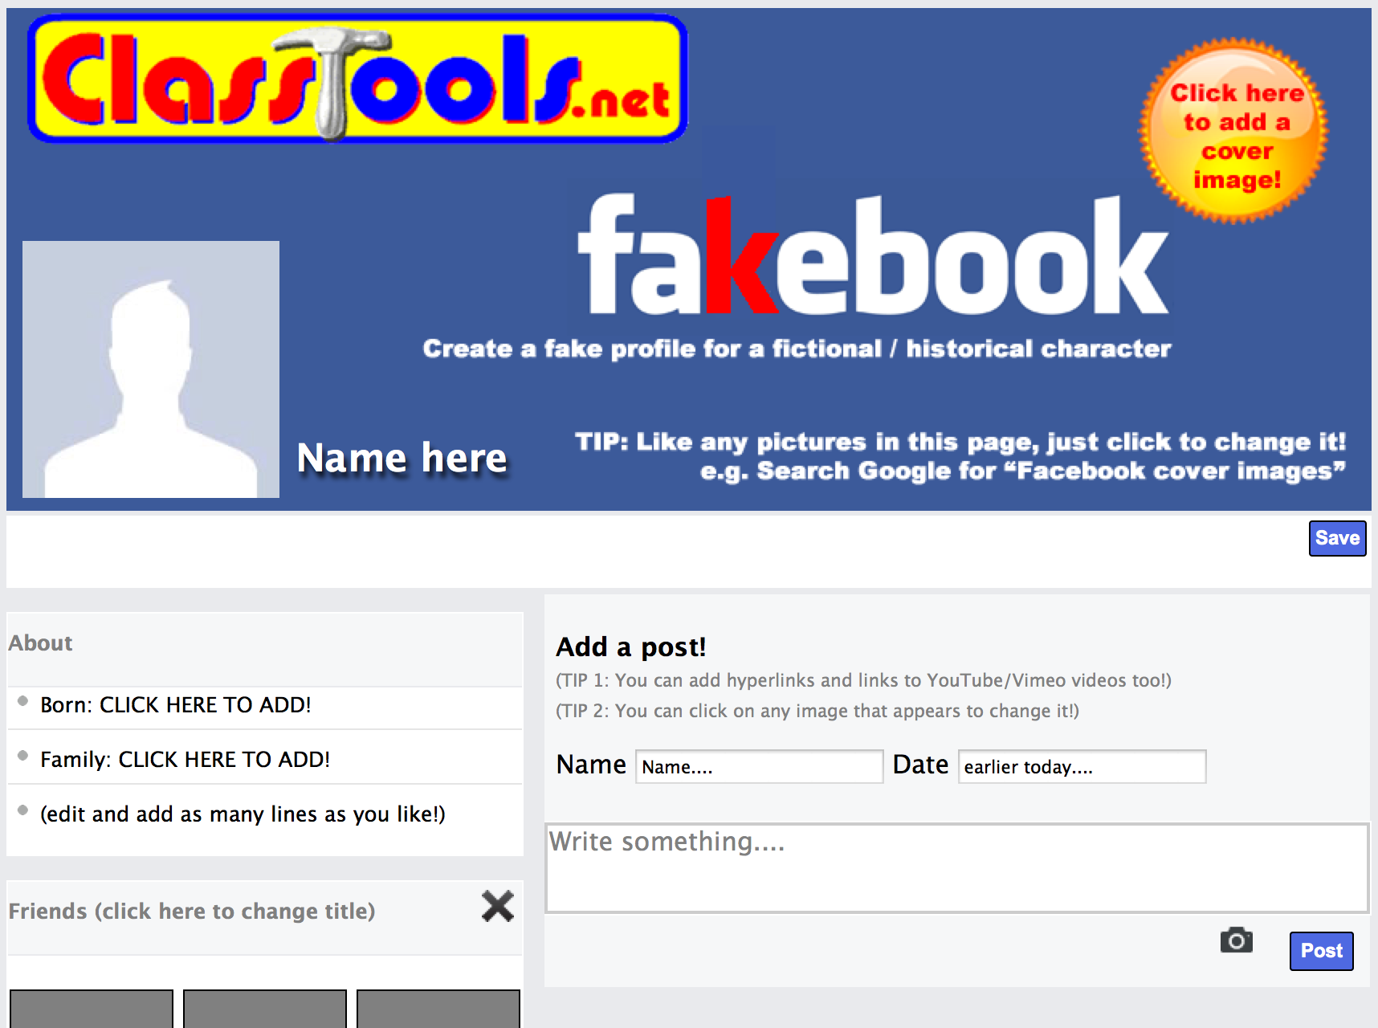

3. Add some key information
about in the ‘About’ box.

4. Start adding some “Friends” in the first block.
You can add as many of these blocks as you like – for example, add another for ‘hobbies’, ‘likes, ‘hates, ‘places visited, ‘favourite books’ and so on.
An image automatically loads. You can click any image to change it.

5. Add a post. Just provide a name, a date, and write something.
You can add hyperlinks and links to YouTube/Vimeo vidoes too.
An image automatically loads. You can click any image to change it.

6. Add a comment and / or a ‘liked by…’ after the post appears.
Like the posts, comments can be ‘dragged and dropped’ with your mouse.

Founding Fathers Facebook Project
As a group, you will research ONE of the founding fathers who was present at the 2nd Consitutional Convention and create a Facebook page online using Fakebook (www.classtools.net/FB/homepage) Use this sheet to complete your research before you begin construction the page and finding pictures.

Create a Facebook Page for a Founding Father using the following guidelines: (3 Points)
- Name of Founding Father at the top of page
- 1 Profile Picture of your historical figure
- 1 background/wallpaper image (relevant)

Basic Information (7 Points)
- Birthdate
- State (Which one is he representing)
- Family Members
- Education
- Occupation
- Religion
- Favorite Quote (Something this person said)

Friend’s Corner
- 6 names and pictures of people that are/would be friends with your figure(6 Points)
  - Think about people from the same state, or who often agreed politically

The Wall
- You must post 5 statuses from your historical figure as if they are posting themselves. (Don’t forget to include dates) Demonstrate that you understand the important events in their life that have made them important, as well as their point of view on the government. (15 Points)
  - Don’t be afraid to use pictures, videos, hashtags, or comments from others.

Personal Information
- 6 Activities/Interests (6 Points)
- 3 Favorite Books/Documents (3 Points)

DON’T BE AFRAID TO BE CREATIVE!! You may add likes, quizzes, and videos- anything that will enhance your project. Your Facebook profile is worth 40 POINTS!

Below are some websites you can use to conduct your research:
http://teachingamericanhistory.org/convention/delegates/
http://www.foundingfathers.info/
http://colonialhall.com/biography.php
http://www.law.umkc.edu/faculty/projects/ftrials/conlaw/marryff.html
http://www.constitutionfacts.com/?section=foundingFathers&page=aboutFathers.cfm
http://www.whitehouse.gov/about/presidents

When finished with your project, e-mail me the link along with your group members names: stephanie.newhall@kcs.k12.nc.us

