**The Battle of Yorktown**

**The Battle of Yorktown**

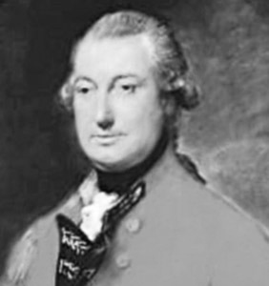

**Cornwallis Waits for Supplies:**

-Led his army to __________________, VA

-Cornwallis was in desperate need of more __________

-Waited for British ships to bring fresh __________ and _________________

**Cornwallis Waits for Supplies:**

-Led his army to __________________, VA

-Cornwallis was in desperate need of more __________

-Waited for British ships to bring fresh __________ and _________________



**Treaty of Paris**

-Americans negotiated in Paris for peace in 1782

1.

2.

3.

1. Britain recognizes U.S. _____________________________________

2. U.S. gets all land from the Atlantic Ocean to the __________________________ River

3. Loyalists would NOT be ________________________

4. Payback any money that they owed each other.

1. Britain recognizes U.S. _____________________________________

2. U.S. gets all land from the Atlantic Ocean to the __________________________ River

3. Loyalists would NOT be ________________________

4. Payback any money that they owed each other.

**Treaty of Paris**

-Americans negotiated in Paris for peace in 1782

1.

2.

3.

**The Siege of Yorktown:**

-By the end of September 1781, ____________ American and French troops trapped Cornwallis’ _____________ British troops at Yorktown

-October 19, 1781-Cornwallis surrendered his troops to the __________________

**The Siege of Yorktown:**

-By the end of September 1781, ____________ American and French troops trapped Cornwallis’ _____________ British troops at Yorktown

-October 19, 1781-Cornwallis surrendered his troops to the __________________

**France Comes to the Rescue:**

-_______________ French troops join American army in ____________ and march 200 miles in 15 days

-20 French ships form a blockade of _______________________________

**France Comes to the Rescue:**

-_______________ French troops join American army in ____________ and march 200 miles in 15 days

-20 French ships form a blockade of _______________________________