**The Battle of Moore’s Creek Bridge**

* **This battled occurred on ______________________, 1776**
* **Between the _____________________ and ____________________living in NC**
* **Great Britain thought that if they could take North Carolina, they could take the entire _____________________**

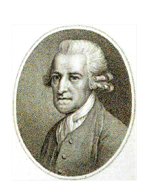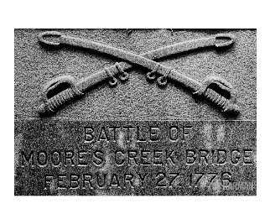

* **Governor________________________ wanted to help Great Britain**
* **Planned to unite North Carolina’s __________________ with British soldiers**
* **They would meet in ________________________________, and both forces would restore British control**

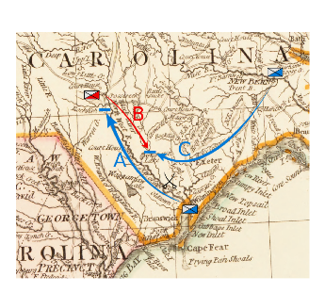

**OUTCOMES:**

**The ___________________________________ & ___________________________ of the South!**

This battle would be called …

* **Patriots hid along the road near ______________________________**
* **They surprised the loyalists trying to cross a ______________________ bridge**
* **Fighting only lasted __________ minutes**
* **___________________ Loyalists were killed or wounded while only one Patriot was killed**

**The Battle of Moore’s Creek Bridge**

* **This battled occurred on ______________________, 1776**
* **Between the _____________________ and ____________________living in NC**
* **Great Britain thought that if they could take North Carolina, they could take the entire _____________________**



* **Governor________________________ wanted to help Great Britain**
* **Planned to unite North Carolina’s __________________ with British soldiers**
* **They would meet in ________________________________, and both forces would restore British control**



* **Patriots hid along the road near ______________________________**
* **They surprised the loyalists trying to cross a ______________________ bridge**
* **Fighting only lasted __________ minutes**
* **___________________ Loyalists were killed or wounded while only one Patriot was killed**

**The ___________________________________ & ___________________________ of the South!**

**OUTCOMES:**

This battle would be called …